

Project Report

**CSE225**

**Section-3**

Submitted by:

Name : MD.Assaduzzaman

I.D. : 2018-1-60-081

Name : Durjoy Barua

I.D. : 2018-1-60-137

Name : Nahid Hasan Ashik

I.D. : 2017-2-60-080

Submitted to:

Mohammad Salah Uddin

Department of Computer Science and Engineering

East West University.

Problem statement:

A space shuttle lift- off from the launch pad has four forces acting on it

Given that,

WB = 1.663 x 106lb

WS = 0.233 x 106lb

TB = 5.30 x 106lb

TS = 1.125 x 106lb

The resultant momentum acting on the craft is equal to zero, when Ө is adjusted to the proper value. The craft will not rotate about its mass center G at liftoff.

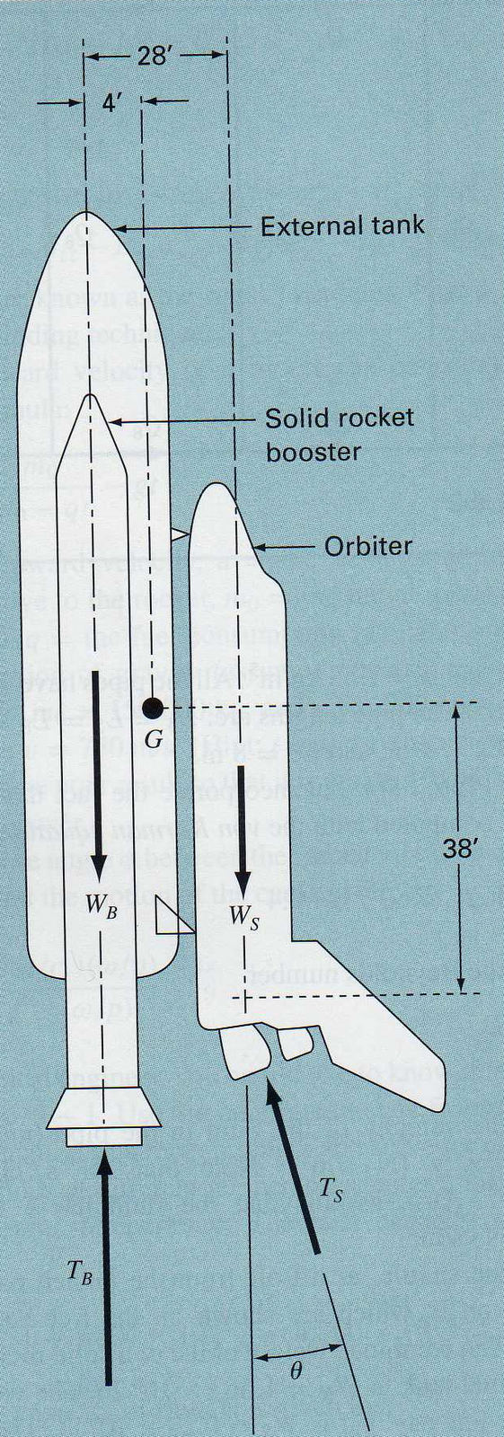

1. The horizontal and vertical components of the orbiter thruster can be computed as,

FH=TSsin𝜃, FV=TScos𝜃

A moment balance about point G can be computed as,

M=4WB-4Ws+24Ws+24Tscos𝜃-38Tssinθ

Here, WB=1.663*10^6lb, Ws=.23*10^6lb, TB=5.30*10^6,

Ts=1.125*10^6lb

Substituting the parameter values yields

M=-20.068*106+27*106cosθ-42.75*106sinθ

Now,

0= -20.068*106+27*106cosθ-42.75*106sinθ

Or, 20.068*106-27*106cosθ+42.75*106sinθ=0

Or, 20.068+42.75sinθ=27cosθ

Or, sinθ+.4694=12/10 cosθ

Or, sin2θ+0.9388sinθ+0.22033=0.39889cos2θ

Or, 1.39889sin2θ+0.9388sinθ-0.17856=0

Or, θ=0.15459 degree

∴ θ=8.892877938rad (in radian)

(b)

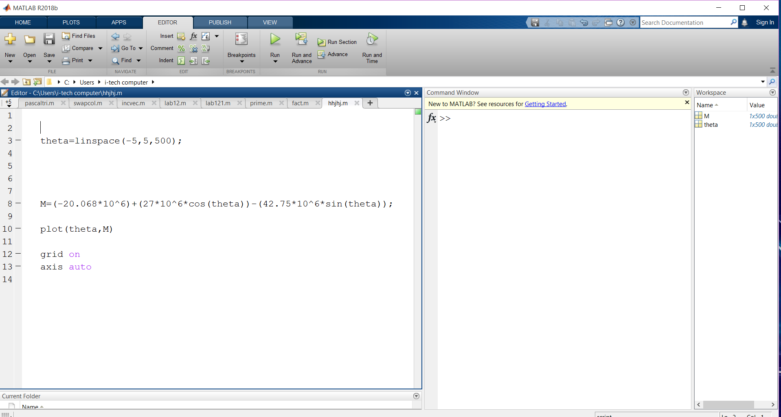

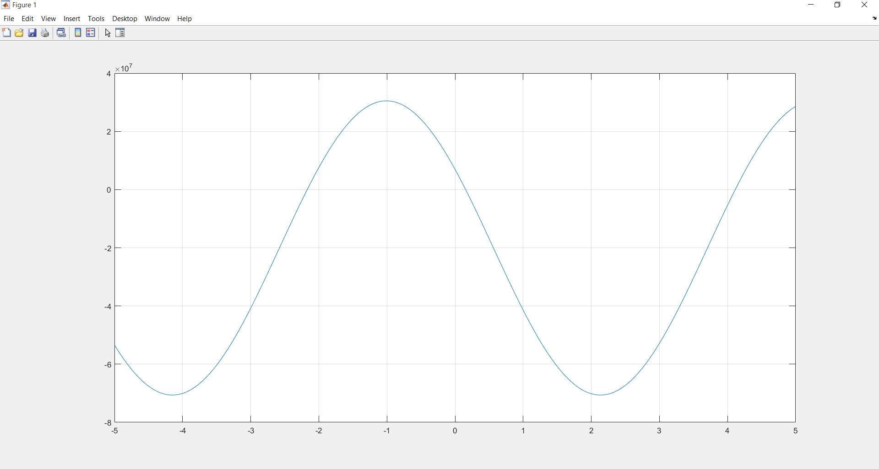

A valid root occurs at about 0.15 radians.

Given range of the angle is -5 to +5 radians.

When, x = -5 then

x = -4 then

x = - 3 then

x = - 2 then

x = - 1 then

x = 0 then

x = 1 then

x = 2 then

x = 3 then

x = 4 then

x = 5 then

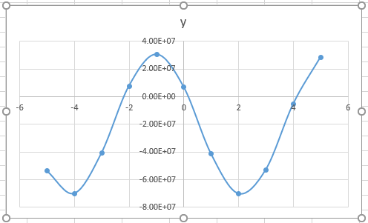

(c)

MATLAB source code and output:

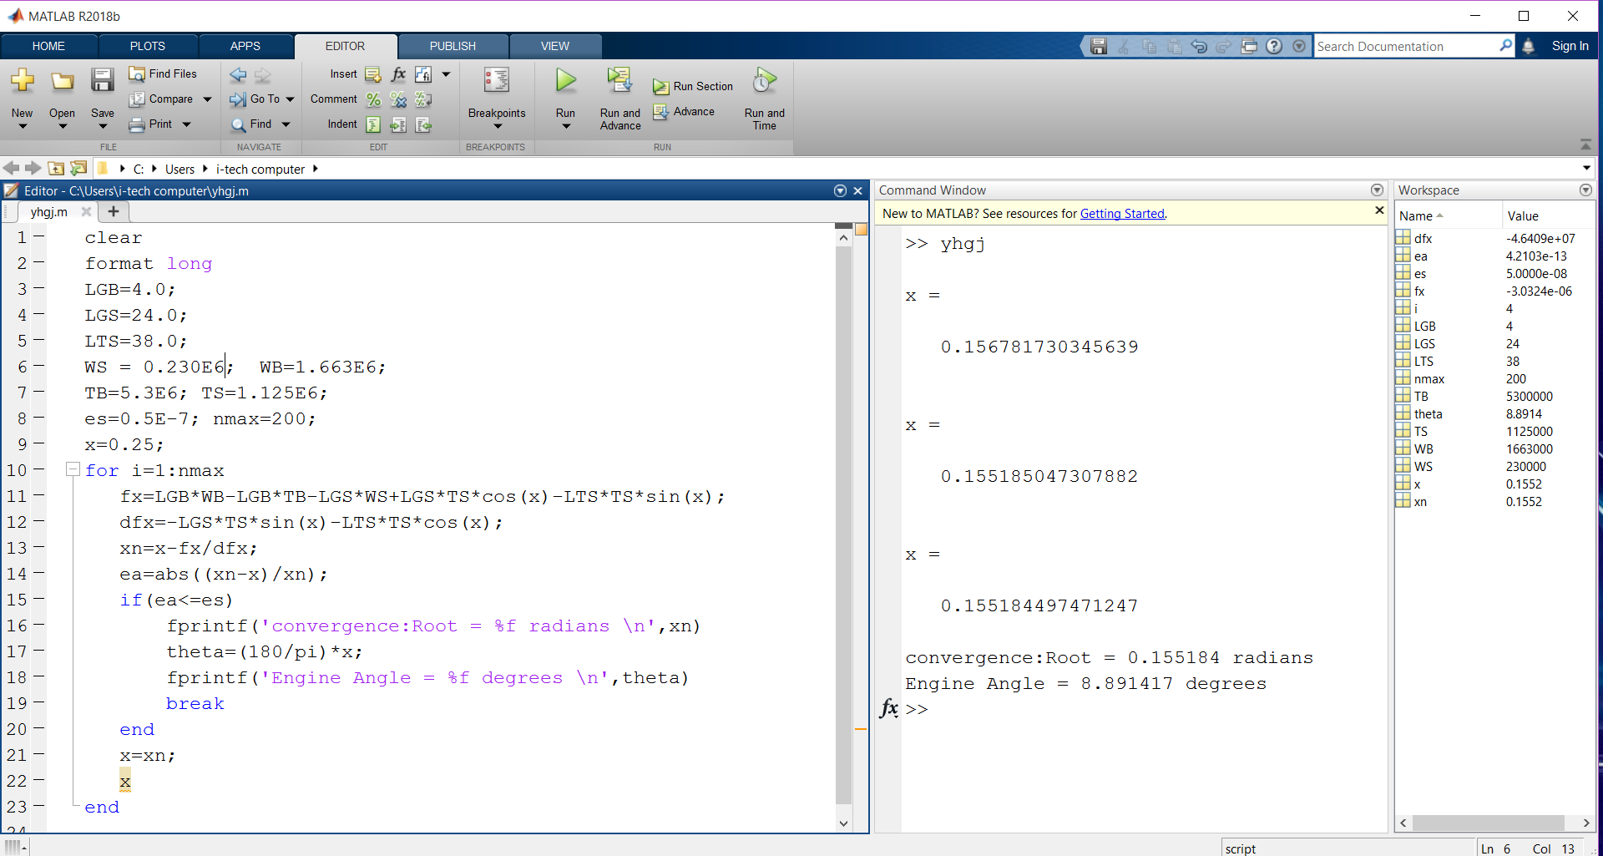

Python 2.7 source code and output:

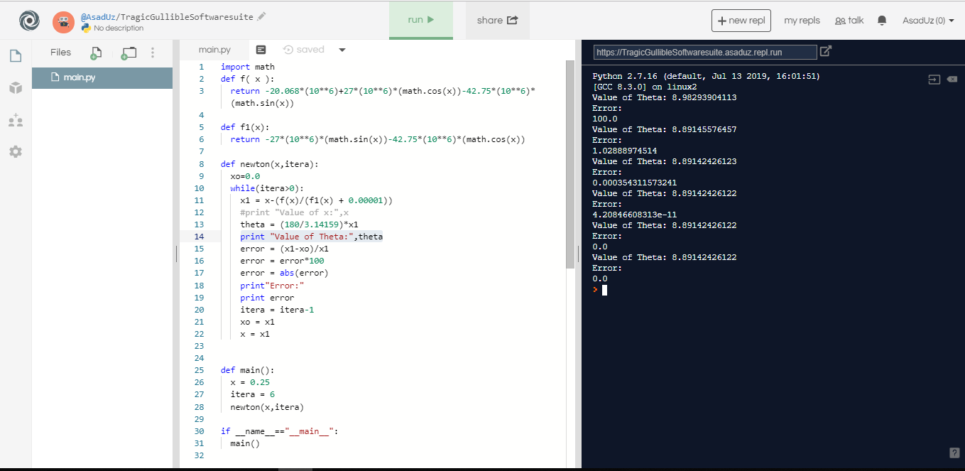

(d)

MATLAB source code and output: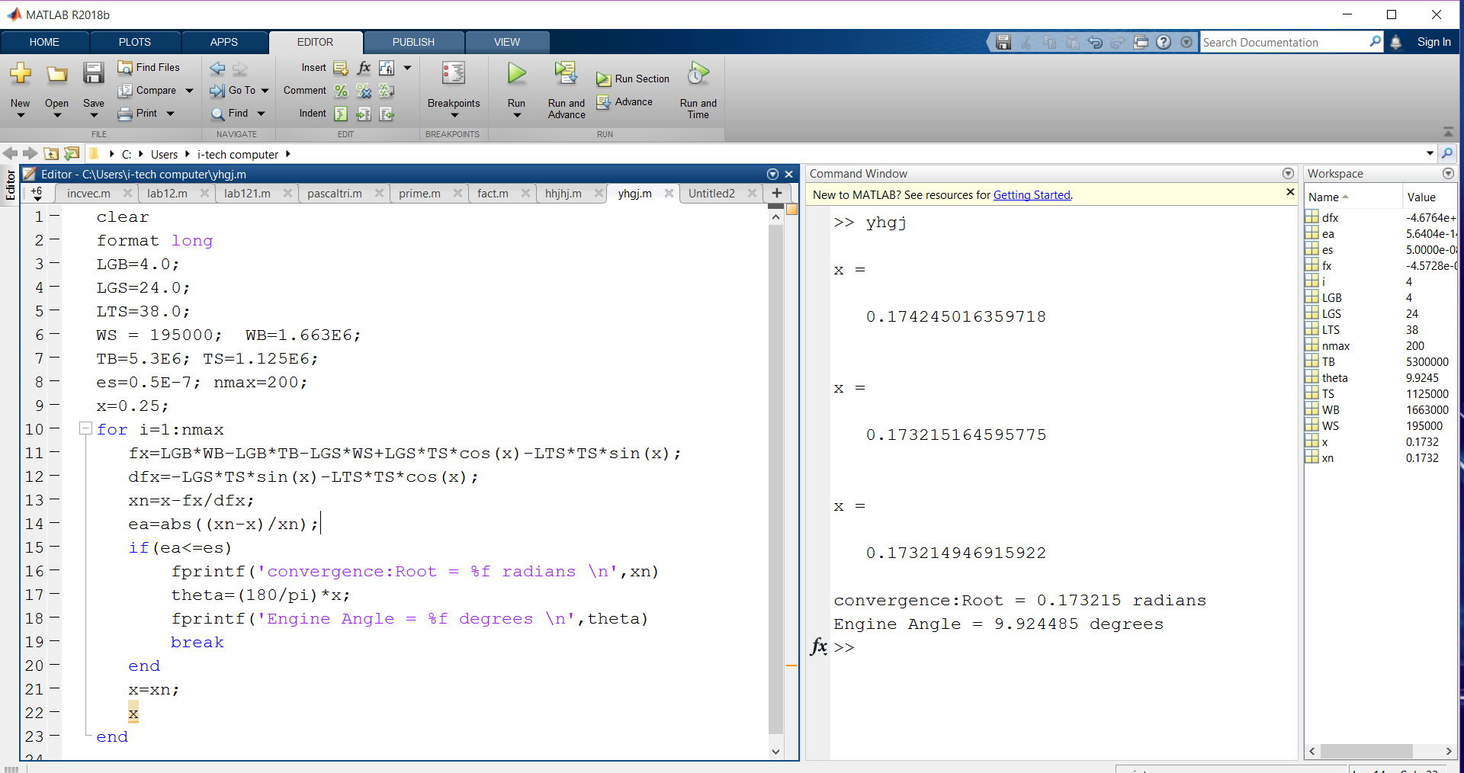

Python 2.7 source code and output:

